**2010 SCIENCE SUPPORT PARTNERSHIP PROPOSAL**

**1. FWS Organization Code:** 20151

**2. Title:** Identification of remaining habitat for the endangered Masked Bobwhite (*Colinus virginianus ridgwayi*); development and validation of a habitat suitability index model.

**3. FWS Project Officer:** Robert Mesta, Coordinator, Sonoran Joint Venture, 738 N. Fifth Ave., Suite 215, Tucson, AZ 85705fax: 520-882-0370; ph:520-882-0047; Robert_Mesta@fws.gov

**4. USGS Contact or Suggested Principal Investigator:**  Dr. Courtney J. Conway, Assistant Unit Leader, USGS Arizona Cooperative Fish and Wildlife Research Unit, 325 Biological Sciences East, University of Arizona, Tucson, AZ  85721; (520) 626-8535; cconway@usgs.gov

**5. FWS Research Coordinator:** Paul J. Barrett, Regional Research Coordinator, 500 Gold Avenue SW, Albuquerque, New Mexico 87102, FAX: 505-248-6287, ph: 702.606.5044, [paul_barrett@fws.gov](mailto:paul_barrett@fws.gov)

**6. Partnerships and Roles:**

Dan Cohan, Refuge Biologist, Buenos Aires National Wildlife Refuge, P.O. Box 109   
Sasabe, AZ 85633; ph: 520-823-4251 x107; fax: 520-823-4247; email: [Dan_Cohan@fws.gov](mailto:Dan_Cohan@fws.gov) (Masked Bobwhite expert)

Sally Gall, Acting Refuge Manager, Buenos Aires National Wildlife Refuge, P.O. Box 109, Sasabe, AZ 85633; ph: 520-823-4251 x103; fax: 520-823-4247; email: [Sally_Gall@fws.gov](mailto:Sally_Gall@fws.gov) (access to BANWR refuge, provide literature on bobwhites, logistics)

John Goodwin, Biologist, Arizona Game and Fish Department (retired), [JGoodwin@azgfd.gov](mailto:JGoodwin@azgfd.gov) (Masked Bobwhite expert)

Robert Mesta, Sonoran Joint Venture Coordinator, U.S. Fish and Wildlife Service, ph: 520-591-4566, [Robert_Mesta@fws.gov](mailto:Robert_Mesta@fws.gov) (logistics in Mexico)

U.S. Geological Survey Arizona Cooperative Fish and Wildlife Research Unit, University of Arizona, Tucson, AZ 85721, ph: 520-626-8535; fax: 520-621-8801; email: [cconway@usgs.gov](mailto:cconway@usgs.gov) (salary for PI, use of field vehicle)

Eduardo Gomez, Biologist, Angela Peralta #61, Hermosillo, Sonora, MX, ph: 011-52-662- 215-5343; [edugomez@hmo.megared.net.mx](mailto:edugomez@hmo.megared.net.mx) (Masked Bobwhite expert, logistics & field work in MX)

Leonard Santisteban, Post-Doctorate Research Associate, School of Natural Resources and the Environment, University of Arizona, Tucson, AZ 85721, ph: 520-621-1959; fax: 520-621-8801; email: lsanti@email.arizona.edu (co-PI)

**7. Type of Support Requested:** Research

**8. Problem Statement and Implications:** The southwestern United States has experienced widespread ecosystem-level changes during the past century due to changes in land-use and water development (Humphrey 1958, Mills et al. 1989, Anable et al. 1992, Archer 1994, Kelt and Valone 1995, Franklin et al. 2006, Rodriguez-Estrella 2007). The impact of largely human-driven changes on biotic communities, particularly native grasslands (Brennan and Kuvlesky 2005), is reflected in a high concentration of federally-endangered bird species in this region of the country (Dobson et al. 1997, Godown and Peterson 2000). One species exhibiting particular sensitivity to landscape alteration and conversion of native Sonoran Desert grasslands is the federally endangered Masked Bobwhite (*Colinus virginianus ridgwayi*; USFWS 1995). The Masked Bobwhite is a subspecies of the Northern Bobwhite that historically inhabited the grassy savannas (llanos) of the level plains and river valleys of south-central Arizona and northern Sonora, Mexico (Brown 1885, 1904, Van Rossem 1945, Ligon 1952, Tomlinson 1972a). Population declines of Masked Bobwhite have been attributed to livestock overgrazing (USFWS 1995), the introduction and spread of invasive grasses (particularly bufflegrass, *Cenchrus ciliaris*; Kuvlesky et al. 2002, Franklin et al. 2006), alteration of natural fire regimes (Cox et al. 1988, Martin et al. 1999), and periods of severe drought-related conditions (Brown 1900, USFWS 1995).

Since the initial discovery of Masked Bobwhite in 1864 (Tomlinson 1972a) and subsequent description in 1884 (Brewster 1885), the species has had a tenuous history. Masked Bobwhite were extirpated in southern Arizona by 1900 and believed extinct in Sonora, Mexico by 1950 (Tomlinson 1972a). Three isolated, wild populations were subsequently re-discovered in Sonora between 1964 and 1992 (Tomlinson 1972b), one or two of which are thought to have since disappeared (Hernandez et al. 2006). During the past 10 years, only two populations were known to exist in the wild, one on the Buenos Aires National Wildlife Refuge (BANWR) and one on several private ranches in north-central Sonora, Mexico (Kuvlesky et al. 2000). Numbers of birds in these two areas have declined in recent years and no birds were detected in either location during the 2009 standardized survey effort (although BANWR staff reported several incidental detections of birds in 2009).

Masked Bobwhite were one of the species that was originally included in the United States Endangered Species Conservation Act of 1968 and the subsequent Endangered Species Act (1973; ESA). The ESA mandates federal protection of endangered and threatened species and their critical habitats and calls for the development of recovery plans for each species. The United States Fish and Wildlife Service (USFWS) is charged with recovering Masked Bobwhite populations in the wild and the sole recovery objective of the USFWS 1995 revision of the Masked Bobwhite recovery plan was “delisting” (USFWS 1995). The last four decades of Masked Bobwhite recovery efforts have seen limited success (Tomlinson 1972b, Russell 1984, Murrieta 1984, Hernandez et al. 2006). The sole population in the U.S. (at BANWR) required annual supplementation of captive-reared individuals. The sole wild population in Mexico is still subject to over-grazing by livestock and limited conservation or habitat management efforts (Murrieta 1984). Successful recovery of the species will require a concerted, international collaborative effort between the United States and Mexico because the 1995 Recovery Plan calls for establishing and maintaining multiple self-sustaining populations in the United States and Mexico (USFWS 1995). Establishing a second population in the U.S. would provide an additional source of individuals (and genetic variation) for the refuge population and therefore reduce the likelihood of extinction resulting from demographic stochasticity or inbreeding depression (USFWS 1995). The recovery plan also calls for the maintenance of the single known Mexican population of Masked Bobwhite (located on private ranches) and the reintroduction of two or more populations throughout Sonora. Lastly, the recovery plan calls for a habitat suitability analysis to guide habitat management and bobwhite reintroduction efforts in the U.S. and Mexico (USFWS 1995). Masked Bobwhite recovery is therefore dependent upon synthesizing Masked Bobwhite habitat requirements, identifying areas with remaining habitat, and managing existing habitat to improve its suitability and availability.

We propose to develop a suite of habitat suitability index (HSI) models for Masked Bobwhite in southern Arizona and Sonora, Mexico. Results from this study will aid species recovery efforts by identifying habitat variables that are important for maintaining existing populations (meeting the objective of ensuring existing populations are viable) (Hernandez et al. 2006). Identifying important habitat variables and modeling habitat suitability at the landscape scale will provide additional guidance for ongoing habitat management efforts at BANWR. Data obtained from this proposed study would also guide habitat management efforts in Sonora where 50,000 acres of critical Masked Bobwhite habitat were identified and protected in 1991 (Dobrott 1991), but which currently receive little to no conservation or management (Murrieta 1984). Habitat suitability models could also be used to identify geographic areas in south-central Arizona and northern Sonora with the most optimal bobwhite habitat, which would increase the probability of successful reintroductions (meeting the objective of establishing a second viable population in the US and two or more in Mexico). Identifying the availability and distribution of remaining bobwhite habitat may also lead to the discovery of additional remnant wild populations. Finally, understanding the distribution of suitable habitat throughout the landscape would allow for an assessment of connectivity among existing or reintroduced populations and opportunities for genetic rescue among populations (Tallmon et al. 2004, Hernandez et al. 2006). This study will therefore serve as the foundation for the next phase of the Masked Bobwhite recovery plan – habitat management and population reintroductions.

**9. Objectives:** The two principle goals for this proposed study are (1) identify habitat relationships for Masked Bobwhite in south-central Arizona and Sonora, Mexico; and (2) develop and test numerous potential habitat suitability models for use in ongoing bobwhite recovery efforts (USFWS 1995). More specifically, this proposed study will address three primary questions. First, what are the ecological conditions that contribute most to Masked Bobwhite habitat? Addressing this question will require compiling a list of habitat variables deemed important to Masked Bobwhite, determining how they are best quantified (e.g., remote sensing, field sampling), and evaluating the relationship between each variable and habitat suitability. Second, what is the best combination of habitat variables for identifying the best remaining Masked Bobwhite habitat? This study will develop a suite of mechanistic habitat suitability models reflecting varying relationships between habitat variables and habitat suitability (i.e., each candidate model will reflect an opinion or idea regarding what best constitutes optimal habitat for Masked Bobwhite). We will then attempt to assess which model performs best at identifying optimal habitat for Masked Bobwhite. Lastly, what areas within the historic range of Masked Bobwhite in south-central Arizona or northern Sonora are suitable for sustaining viable Masked Bobwhite populations? Habitat suitability models will be used to identify areas that have the best remaining bobwhite habitat. These areas can then be given priority for future surveyor efforts to help determine whether remnant, wild populations still exist. The models will also help to identify locations for future reintroductions and inform future habitat management efforts.

**10. Methods and Study Area:** The goals outlined for this proposed study will require completion of several key stages, each drawing upon information from 4 sources: Masked Bobwhite experts, published literature, field research, and computer modeling. The 6 stages of this proposed study include:

1. *Compile a list of habitat variables important to Masked Bobwhite that might be included in one or more of the candidate HSI models.* We will begin by synthesizing all available information on habitat requirements of Masked Bobwhite. Most of the information available on habitat ecology of the Masked Bobwhite consists of qualitative habitat descriptions dating back to the late 1800s and more recent (but few) quantitative analyses conducted in the 1990s (reviewed by Hernandez et al. 2006). Early author’s descriptions of Masked Bobwhite habitat generally agree upon the importance of five key habitat characteristics: level terrain, moderate elevation, abundant herbaceous cover, interspersed woody cover, and abundant seed-producing plants (see review by Hernandez et al. 2006). Tomlinson (1984) reported seasonal changes in Masked Bobwhite habitat use; open grasslands were most often used by bobwhite during the summer and adjoining brushy areas (shrub lands) used more during the non-breeding season. Landscape-scale variables will be included in some candidate models to try to account for seasonal shifts in habitat requirements. We will focus on habitat variables that can be effectively quantified and used to identify and assess remaining Masked Bobwhite habitat. The habitat requirements for Masked Bobwhite are thought by some authors to be very similar to those of Northern Bobwhite (*C. virgianianus*) (Guthery et al. 2001a; Hernandez et al. 2006, Brennan 1999). Consequently, we will include optimal habitat conditions for Northern Bobwhite in several of our candidate models. A preliminary list of habitat components to consider in habitat suitability models for Masked Bobwhite (King et al. 1996, Reichenbacher and Mills 1984, Simms 1989) includes: grass species richness, forb species richness, % herbaceous cover, herbaceous biomass, % shrub cover, woody vegetation structure, % bare ground, elevation, soil type, rainfall, proximity to water/wet areas, abundance of bufflegrass, relative humidity.

2. *Determine the most effective way to measure focal habitat variables.* We will attempt to determine the appropriate spatial scale at which to quantify each variable based on conversations with species experts and information in the literature. For example, grass or forb species richness may require sampling at a local scale with on-site vegetation sampling techniques (Morrison et al. 1998), whereas other variables (e.g., percent shrub cover or percent bare ground) might best be measured at larger spatial scales with aerial photography or remote sensing techniques. Geographic relationships at the landscape scale can be measured via existing GIS or climate-related databases. After determining the spatial scale at which each habitat variable is best measured, we will then seek consensus on the sampling technique most appropriate for each variable. Some variables will be quantified following standard vegetation sampling protocols, such as fixed-area sampling plots for grass species diversity, while other habitat variables will be estimated from aerial photos or GIS data layers.

3. *Describe the relationship between each habitat variable and suitability* *for Masked Bobwhite*. We will create univariate graphs to describe the relationship between each habitat variable and suitability for Masked Bobwhite. These ‘suitability index graphs’ will be based on general statements describing Masked Bobwhite habitat requirements in the literature or from expert opinion. For example, Goodwin (1982) noted that Masked Bobwhite prefer areas with 5 to 10 species of grasses and 10 to 15 species of forbs. The suitability index curve for grass diversity would therefore indicate maximum suitability (i.e., suitability score of 100%) between 5 and 10 species of grasses and lower suitability for either <5 or >10grass species, as shown in Figure 1. We will then present these suitability index graphs to a suite of Masked Bobwhite experts and ask them to refute or refine these relationships until consensus (to the extent possible) is reached. We will reconcile any lack of consensus among experts by generating a separate candidate model that accurately portrays each opinion (see below).

4. *Develop a suite of candidate habitat suitability models*. Habitat suitability index (HSI) models are based on the functional relationship between habitat variables and wildlife (Larson et al. 2003) and, in this case, are useful for coalescing the habitat variables believed to influence habitat suitability for Masked Bobwhites. This proposed study will develop a suite of candidate habitat models because each model may be viewed as a hypothesis describing bobwhite-habitat relationships (Schamberger et al. 1982). HSI models will then be used to estimate habitat quality—on a suitability index scale ranging between 0 and 1—throughout the historic range of Masked Bobwhite. HSI models will be constructed using suitability index graphs developed in step 3 and associated suitability index (SI) scores for a given habitat. Suitability index scores compare existing habitat conditions in an area to the relationship described by individual suitability index graphs (USFWS 1981). Scores for individual habitat variables within existing bobwhite habitat are interpolated directly from the suitability index graph. Continuing with the grass species richness example from above, a habitat containing 3 species of grasses would result in a suitability index score of 0.6 for that variable (Figure 1). SI scores for each habitat variable will then be aggregated into a component index (CI) score of suitability. CI scores for a given habitat will then be coalesced into a habitat suitability index score. The technique used to aggregate scores will depend upon the functional relationships between individual habitat variables or habitat components (e.g., limiting factor, cumulative, compensatory; USFWS 1981). The HSI score for a specified area will ultimately provide an estimate of the suitability of that habitat to Masked Bobwhite (Morrison et al. 1998). We will also attempt to account for uncertainty in the modeling process by estimating confidence intervals around HSI estimates (Bender et al. 1996). Some HSI models (e.g., those that rely solely on aerial photo or remote sensing variables) might then be used to develop a GIS model (e.g., in ArcMap and ERDAS) to map suitable habitat in southern Arizona and Sonora, Mexico.

5. *Validate the candidate HSI models*. A multi-stage model verification process will be implemented to ensure that the final HSI model is appropriate for addressing the goals and objectives outlined above. HSI models will first be carefully reviewed by personnel directly involved in model development. Second, HSI models will be evaluated with sample data sets mimicking a wide range of habitat conditions to determine how well each candidate model identifies bobwhite habitat. Third, the suite of candidate HSI models will be sent to Masked Bobwhite experts to ask whether additional candidate models should be considered. Finally, HSI models will be field-tested in areas last known to support wild Masked Bobwhite populations.

6. *Identify remaining available habitat suitable for Masked Bobwhite.* The best-performing model will be used to identify areas within the historic range of Masked Bobwhite with the highest potential for having remaining habitat. This information will be useful because it will allow USFWS and others to identify the most suitable areas for additional Masked Bobwhite surveys with the goal of discovering previously unknown bobwhite populations. It will also allow them to identify (and rank) areas suitable for Masked Bobwhite reintroductions, supporting the Masked Bobwhite recovery plan’s objectives of establishing two self-sustaining populations in Arizona and two or more in Sonora (USFWS 1995). Lastly, HSI models could be used to evaluate areas on BANWR and other areas of southeastern Arizona to evaluate their suitability as bobwhite habitat which will aid ongoing habitat management efforts aimed at creating favorable habitat characteristics (USFWS 1995).

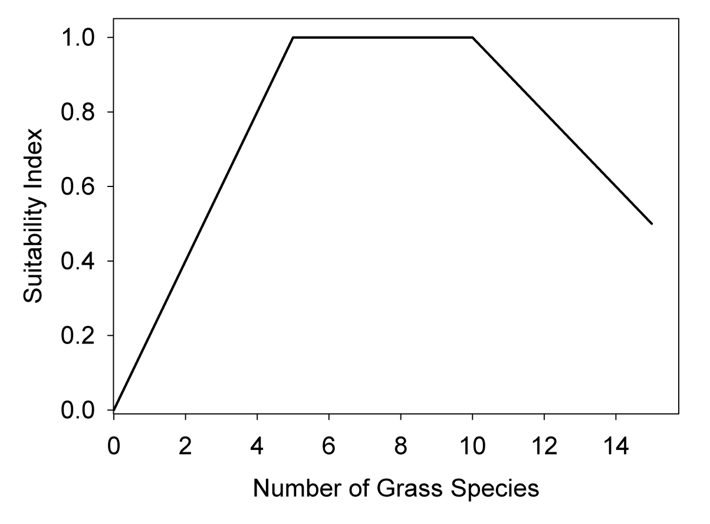**Figure 1**. Suitability index graph describing the hypothetical relationship between diversity of grasses and the suitability index (SI) score for Masked Bobwhite (based on Goodwin 1982).

**11. Project Duration:** 1 Oct 2010 – 31 Dec 2013

**12. Priority**: Endangered Species Recovery Plan, 5-year review, and recovery team priority.

**13. Products and Schedule**:

30 Sep 2011 Annual Report, including a list of variables that best describe optimal habitat conditions, how best to measure them, their functional relationship with suitability, and a suite of candidate habitat models, .rtf format.

30 Sep 2012 Annual Report, including a final list of habitat models taking into account input from all species experts, and ranked in priority based on model validation efforts from implementing models in areas where masked bobwhite were last detected, .rtf format.

30 Sep 2013 Final Report. This document will provide a ranked list of priority habitat models, identify areas within the historic range that hold the best hope for finding extant populations (or for reintroducing captive birds), and provide key guidance to aid recovery of Masked Bobwhite, .rtf format.

31 Dec 2013 Publication of 1 or 2 scientific journal articles for further dissemination of this research (with understanding that timing of article publication can be variable).